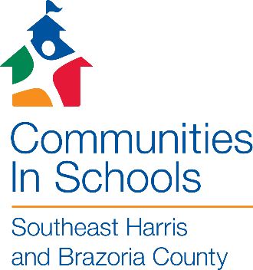 |  | 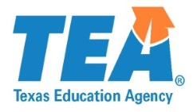

Dear Parent or Guardian,

My name is Maria T. Rodriguez and I am your Site Coordinator for Communities In Schools (CIS) at Green Valley Elementary

We are pleased to invite your child to participate in our CIS program. CIS is dedicated to meeting the needs of our children through a team of professionals working together to provide supportive guidance, health and human services, parental involvement, pre-employment, enrichment, and academics in a personal one-on-one relationship. CIS supports the students’ positive growth and achievement by addressing individual needs in a caring, personalized, holistic, and accountable manner. Participants in the CIS Program will receive services without discrimination based on race, age, religion, national origin, marital status, veteran status, sexual orientation, disability or gender.

During the school year, your child will participate in enrichment and academic activities. This may include individual tutoring, mentoring, peer mediation, homework groups, boys and girls groups, field trips, arts and crafts, and recreational activities. CIS also provides supportive guidance that will allow the student to improve attendance, academic performance, and behavior.

We believe that your child will benefit from involvement in CIS. All services are provided at NO COST to the children and their families who are enrolled in the CIS program.

Please complete the attached Parent consent form and return it at your earliest convenience. This information is needed before your child can participate in CIS activities.

Please feel free to call or contact me if you have any questions at 832-386-4397.

Thank you and we look forward to working with you and your child.

Thank you,

Maria T. Rodriguez
Communities In Schools
Green Valley Elementary
School Phone: 832-386-4390

